Lecture 6

- Simple Linear Regression Analysis:
- Capturing the effect of one independent or explanatory variable (x) on the dependent or explained variable (y), i.e., capturing the “causal relationship (cause and effect)” between two variables, with real-world data. For example,
- University enrollment (y) vs. tuition (x)
- Home sales (y) vs. home mortgage rate (x)
- Sales (y) vs. advertising expense (x)
- Labor supply (y) vs. wage (x)
- Imports (y) vs. domestic income (x)
- Such a causal relationship can exist in time-series as well as cross- sectional data.
- An example (in ‘000):
Company | Cars, x | Revenue, y
Alamo | 130 | 1180
Avis | 190 | 1500
Budget | 126 | 1500
Dollar | 63.5 | 560
Enterprise | 315.1 | 2060
FRCS (Ford) | 55.25 | 312.5
Hertz | 250 | 2400
National | 135 | 1200
Payless | 15 | 47
PROP (Chrysler) | 27 | 160
Rent-A-Wreck | 10.9 | 78
Snappy | 15.5 | 85
Thrifty | 34 | 340
U-Save | 13.5 | 95
Value | 18 | 150.1

- The question: Does the number of cars in the car rental company’s fleet (x, in thousands) affect company’s revenue (y, in thousands of dollars)? If so, in what manner? Is the effect positive or negative? Is the empirical evidence statistically significant to justify such a causal effect?
- Typically one will start with a “scatter plot” to visually capture the possible causal relationship between x and y. Each dot is a number pair of x and y on the x-y dimension.
- General shapes of scatter plots:

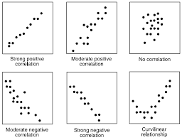

- With our rental car company example above, first input the data on “cars” (x) and “revenue” (y) into two separate columns and then use the charting tool “Scatter” in EXCEL.
- With “cars” on the horizontal axis and “revenue” on the vertical, the finished product (scatter plot) looks like the following:

- It is rather clear from the scatter plot above that there is a positive relationship between “cars” and “revenue”, and further, more cars in the fleet seem to drive rental car company’s revenue up! Is this evidence significant? Formal statistical testing is needed to verify! The simple linear regression analysis provides a perfect tool to investigate such a causal relationship!
- Adding a “trendline,” the direction of the relationship becomes even more apparent:
  - The trendline best matches or fits the “dots,” i.e., the line goes through the data area on the plot in the tightest manner with the shortest “vertical” distances to all dots.

- The fundamental purpose of the simple linear regression analysis is to empirically identify or estimate such a trendline or “the best fitted line”, based on a linear mathematical function.
- In general, a linear mathematical function carries the format:
y = a + bx, where a is the vertical intercept and b is the slope. If b is positive, it means that when x increases (decreases), y also increases (decreases); if b is negative, it means when x increases (decreases), y decreases (increases). As a graphical example, when b is positive, the line looks like the following:

y

Δy Δy b = Δy/Δx
Δx

a

0 x
Δx

- Based on a mathematical straight line (linear) function, a simple linear regression model with one independent variable can be specified as:
$$y_{i}= β_{0}+ β_{1}x_{i}+ε_{i}$$
where i refers to the ith observation, and i = 1, 2 3, …, n. n is data size.
- On the right-hand-side of the model, $β_{0}+ β_{1}x_{i}$ is called the “deterministic term,” i.e., this part of the connection with the y variable on the left-hand-side is pretty much set except that one needs to estimate the two unknown population parameters, β₀ (the vertical intercept) and β₁ (the slope) with data.
- Following simple geometry, β₀ controls the vertical position of the linear function $y_{i}= β_{0}+ β_{1}x_{i}$, while β₁ is the slope term and captures the effect on y as x changes.
- When β₁ is positive, it means when x increases, y increases as well; when β₁ is negative, it means when x increases, y decreases; when β₁ is zero, it means whatever the change in x is, there is no impact on the y variable.
- The other term on the right-hand-side of the regression model, ε_{i} (epsilon), is called the “random error term,” the “disturbance term,” or simply the “error term.” This reflects the fundamental difference between a mathematical straight line equation and a linear regression model.
- No one knows the truth completely! We are bound to miss something – because of our choice, because of our analytical ability, or because of some random process – in the analysis. We are guessing in a scientific way with real world data!
- ε_{i} is a compound term that captures the impact on the dependent variable y from all other factors or variables (other than the x variable included in the regression model). Remember we choose to include only the x variable, but not the others.
- ε_{i} covers two groups of factors or variables:
- those important but un-included independent variables;
- those totally random factors, such as sudden adverse weather conditions.
- Although practically unlikely, if ε_{i} does not exist, the deterministic part of the model $β_{0}+ β_{1}x_{i}$ can fully explain the dependent variable y. The fact that ε_{i} typically exists “disturbs” the relationship between y_{i} and $β_{0}+ β_{1}x_{i}$, hence the name the “disturbance term.”
- Therefore, any regression model requires specification of both the deterministic term (with the choice of the x variable or variables) and the disturbance term in order to fully capture the “story” in the dependent variable y.
- The best way to statistically “run” the regression model is by following the so-called the Ordinary Least Squares method (OLS).
- The OLS method provides the best line fit to the “dots” or data observations, i.e., it ensures shortest “vertical” distances between data observations and the fitted line:

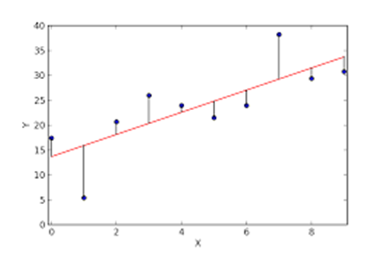

- However, the OLS method requires full satisfaction of the following classical assumptions regarding the disturbance term, ε_{i}:
- zero mean: $μ_{ε}=0$ for every ε_{i}
- constant variance: $σ_{ε}^{2}$ = a constant for every ε_{i}
- normally distributed for every ε_{i}
- ε_{i} and ε_{j} are independent, for i ≠ j.
- Any violation of these assumptions invalidates OLS and would require corrections and a different regression method to ensure statistically meaningful results.
- The OLS fitted equation or the OLS line:

$${\hat{y}}_{i}= b_{0}+ b_{1}x_{i}$$
where ${\hat{y}}_{i}$ is the fitted or predicted value of the dependent variable y_{i}, given $x_{i}$, and $b_{0}$ and $b_{1}$, which are the OLS estimates for β₀ and β₁, respectively.
- Deviations, $y_{i}- {\hat{y}}_{i}$, for all i, can then be defined and measured between the actually observed value of the dependent variable, y_{i}, and its corresponding predicted value, ${\hat{y}}_{i}$.
- Each deviation, $y_{i}- {\hat{y}}_{i}$, is an “error” or “residual” created from regression! It is typically denoted as

$e_{i}= y_{i}- {\hat{y}}_{i}$, i = 1,2,…,n.

- In an ideal situation, $y_{i}= {\hat{y}}_{i}$. But this is not going to happen!
- Theoretically, the purpose of OLS is to

Minimize SSE = $\sum{e_{i}^{2}}=$ $\sum{{(y_{i}- {\hat{y}}_{i})}^{2}}$,

which is called SSE (Sum of Squared Errors), by choosing the best possible values for $b_{0}$ and $b_{1}$. In a way, this formula gives the total amount of errors created by adopting OLS in an attempt to capture the story in the dependent variable y.
- Solving the above minimization model yields the following formulas the estimates $b_{0}$ and $b_{1}$(skipping all subscripts i):
$$b_{1}=\frac{{SS}_{xy}}{{SS}_{xx}}= \frac{\sum{(x- \overline{X})(y- \overline{Y})}}{\sum{{(x- \overline{X})}^{2}}}= \frac{\sum{xy}-n\overline{X}\overline{Y}}{\sum{x^{2}-n{\overline{X}}^{2}}}$$

$$b_{0}= \overline{Y}- b_{1}\overline{X}$$
- However, the truth is in β₁ (the parameter), not b₁ (the estimate).
- To repeat:
- Expanded version of the simple linear regression model based on observations:

y₁ = β₀ + β₁x₁ + ε₁
y₂ = β₀ + β₁x₂ + ε₂
y₃ = β₀ + β₁x₃ + ε₃
y₄ = β₀ + β₁x₄ + ε₄
. .
. .
. .
y_{n} = β₀ + β₁x_{n} + ε_{n}

- In OLS, all of the ε₁’s follow the classical assumptions:
- zero mean: $μ_{ε}=0$ for every ε_{i}
- constant variance: $σ_{ε}^{2}$ = a constant for every ε_{i}
- normally distributed for every ε_{i}
- ε_{i} and ε_{j} are independent, for i ≠ j.

- After applying OLS to minimize SSE:
$y_{i}= \hat{y_{i}}{ + e_{i}=b}_{0}+ b_{1}x_{i}+e_{i}$
- Using the rental car company example, the OLS results are:
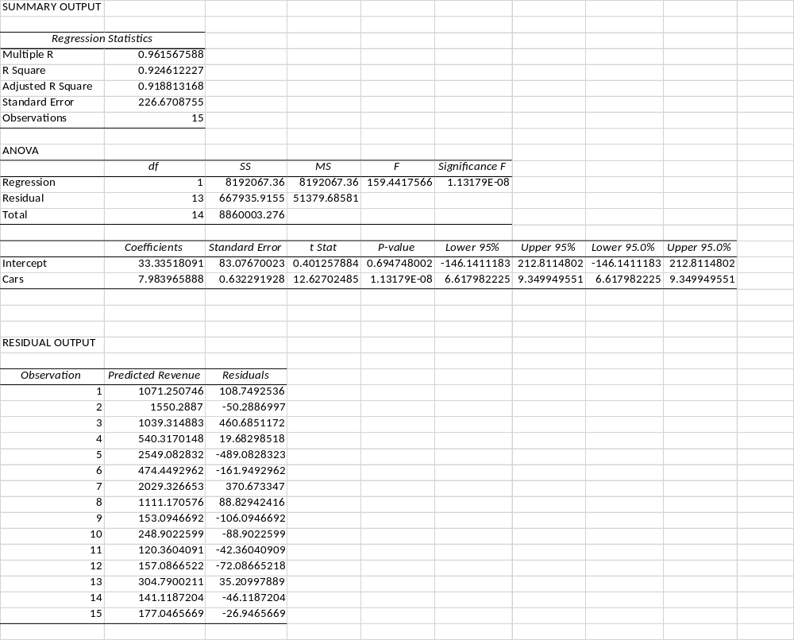

- A type of exam question that could appear in the test looks like the following: 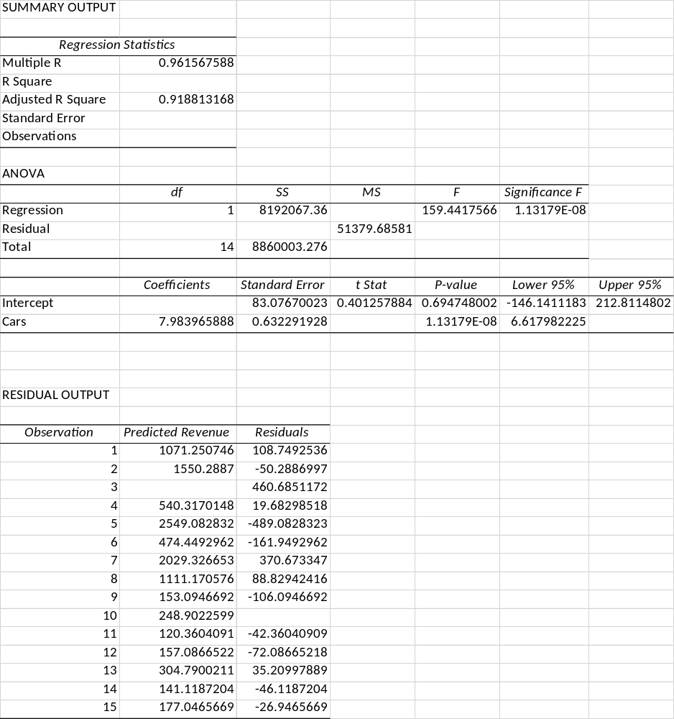

- Standard format of the simple linear regression output in EXCEL:

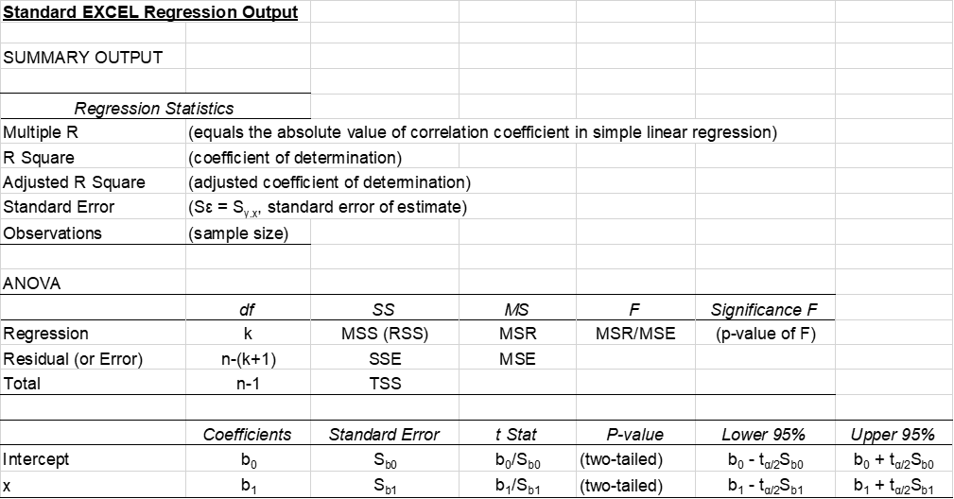

- Statistical inference for β₁, based on b₁:
- Estimated standard error of ε_{i} (to estimate σ_{ε}):
$$s_{ε}= \sqrt{MSE}=\sqrt{\frac{SSE}{n-2}}$$
$$= \sqrt{\frac{\sum{e_{i}^{2}}}{n-2}}= \sqrt{\frac{\sum{{(y_{i}- {\hat{y}}_{i})}^{2}}}{n-2}}$$
where MSE stands for Mean Squared Errors.
- $s_{ε}$ can also be treated as the estimated standard error of the y variable, given x, denoted as s_{y.x}. This is because the entire variation of y is determined by the only random component of the regression model, ε, i.e., y and ε share the same degree of variability. That is why s_{y.x} can also be called the “standard error of the (regression) model.”

- Standard error of b₁:

$$s_{b_{1}}= \frac{s_{ε}}{\sqrt{\sum{x^{2}-n{\overline{X}}^{2}}}}$$
- Confidence interval estimation for β₁:
$b_{1 }± t_{α/2}s_{b_{1}}$, df = n - 2
- Test of hypothesis for β₁:
    - Test statistic:
$t_{0}=\frac{b_{1}-{{(β}_{1})}_{0}}{s_{b_{1}}}$ , df = n – 2

And if ${{(β}_{1})}_{0}$ = 0,
$t_{0}=\frac{b_{1}}{s_{b_{1}}}$

  - Choices of hypotheses:

Two-tailed test:

$$\left\{\begin{matrix}H_{0}:{ β}_{1}= {{(β}_{1})}_{0} \\ H_{1}:{ β}_{1}≠ {{(β}_{1})}_{0}\end{matrix}\right.$$

Right-hand-side-tailed test:

$$\left\{\begin{matrix}H_{0}: { β}_{1}≤ {{(β}_{1})}_{0} \\ H_{1}: { β}_{1}> {{(β}_{1})}_{0}\end{matrix}\right.$$

Left-hand-side-tailed test:

$$\left\{\begin{matrix}H_{0}: { β}_{1}≥ {{(β}_{1})}_{0} \\ H_{1}: { β}_{1}< {{(β}_{1})}_{0}\end{matrix}\right.$$

  - The rest of the test is the same as the regular t test. No Z test!

- The Coefficient of Determination, r² – indicating the overall usefulness of the regression model:

      - Total variation in y (TSS)
=
Explained variation in y (RSS)
+
Unexplained variation in y (SSE)

      - TSS: Total Sum of Squares

$\sum{{(y_{i}-\overline{Y})}^{2}}$

RSS: Regression Sum of Squares

$\sum{{({\hat{y}}_{i}-\overline{Y})}^{2}}$

SSE: Sum of Squared Errors

$\sum{{(y_{i}- {\hat{y}}_{i})}^{2}}$

      - TSS = RSS + SSE

RSS = TSS – SSE

$$r^{2}=\frac{RSS}{TSS}=\frac{TSS}{TSS}-\frac{SSE}{TSS}$$

      - 0 ≤ $r^{2}$≤ 1; The closer it is to one, the better. When it is closer to 0, the regression provides a bad fit.
      - Officially, the coefficient of determination, R², determines the percentage of the total variation in y (the actual “story” in y) that has been explained by the regression model with x being the independent variable.

- The (Pearson) correlation coefficient, r, between two variables x and y:
    - Correlation: the extent to which two variables are related through data.
    - The correlation coefficient can be deceiving as one can borrow any two variables and generate a value of the correlation coefficient, regardless of whether these two variables are actually related or not.
    - Observing correlation between two variables through a scatter plot or scattergram:

- Example 1: a (strong) positive or direct relationship

Student | SAT-V Score | 1st Year GPA
A | 333 | 1.00
B | 756 | 3.80
C | 444 | 1.90
D | 629 | 3.20
E | 501 | 2.30
F | 245 | 0.40
- Example 2: a (strong) negative or inverse relationship

Participant | Self Esteem | Depression
A | 12 | 25
B | 12 | 29
C | 10 | 38
D | 7 | 50
E | 8 | 61
F | 4 | 72
- Example 3: a weak (or no) relationship

Student | SAT-V Score | 1st Year GPA
A | 333 | 1
B | 756 | 3.8
C | 444 | 1.9
D | 629 | 3.2
E | 501 | 2.3
F | 245 | 0.4
G | 630 | 0.9
H | 404 | 3.1
- The Pearson correlation coefficient, r:

$$r=\frac{\sum{(x_{i}-\overline{X})}(y_{i}-\overline{Y})}{\sqrt{{\sum{(x_{i}-\overline{X})}}^{2}\sum{{(y_{i}-\overline{Y})}^{2}}}}$$

$=\frac{n\sum{xy-\sum{x\sum{y}}}}{\sqrt{n\sum{x^{2}-{(\sum{x})}^{2}}}\sqrt{n\sum{y^{2}-{(\sum{y})}^{2}}}}$

- The coefficient can only range from -1.00 to 1.00.
- -1.00 indicates a perfect inverse relationship. All data pairs can be located along a negatively sloped straight line on the scattergram.
- 1 indicates a perfect positive relationship. All data pairs can be located along a positively sloped straight line on the scattergram.
- 0 indicates the complete absence of a relationship. No pattern can be identified on the scattergram.
- The closer it is to 0.00, the weaker is the relationship.
- The closer it is to -1.00 or 1.00, the stronger is the relationship

- Hypothesis test for ρ, the population correlation coefficient:

$$t_{0}=\frac{r}{\sqrt{\frac{1-r^{2}}{n-2}}}$$

with df = n – 2.

Example Set 5
Spring 2020

1. As a result of the increase in suburban shopping centers, many downtown stores are suffering financially. A downtown department store thinks that increased advertising might help lure more shoppers into the area. To study the effect of advertising on sales, records were obtained for several midyear months during which the store varied advertising expenditures. Those records are shown in the table below:

Advertising Expenses ($1,000) Sales ($1,000)
0.9 30
1.1 34
0.8 32
1.7 37
  - 31

(a) Following the simple linear regression model (y_{i} = β₀ + β₁x_{i} + ε_{i}) and using the regression tool in EXCEL, find the OLS equation: ${\hat{y}}_{i}= b_{0}+ b_{1}x_{i}$, relating sales (y) to advertising expenses (x).
(b) Find the predicted values (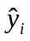) and the residuals (e_{i}).
(c) Find SSE, MSE, and S_{b1}.
(d) Find the 90% confidence interval for the slope parameter, β₁. Interpret the y
interval.
(e) Test to see if higher advertising expenses help attract more shoppers, and hence increase sales. Use α = 0.01. Explain your result.
(f) If the department store spends $1,500 on advertisement in a certain month, how much sales would you expect this store to generate, holding other things constant?
(g) Find r², the coefficient of determination, for this regression. Interpret its
value.

2. The reasons given by workers for quitting their jobs generally fall into one of two categories: (1) worker quits to seek or take a different job, or (2) worker quits to withdraw from the labor force. Economic theory suggests that wage (x) affects quit rate (y). The least squares regression results based on the data on quit rates and average hourly wages from 15 industries are given below [with a few numbers hidden].

SUMMARY OUTPUT
Regression Statistics
Multiple R | (1)
R Square | (2)
Adjusted R Square | 0.70772395
Standard Error | (3)
Observations | (4)
ANOVA
 | Df | SS | MS | F | Significance F
Regression | (5) | (8) | 8.250676 | (11) | 5.17103E-05
Residual | (6) | (9) | (10)
Total | (7) | 11.324
 | Coefficients | Standard Error | t Stat | P-value | Lower 95% | Upper 95%
Intercept | 4.86148994 | 0.520065796 | 9.347836 | 3.9119E-07 | 3.73795631 | 5.985023567
Average Wage, x | -0.34655055 | (12) | -5.9076155 | 5.171E-05 | (13) | -0.219819762

Find the values in the EXCEL chart with (#) [(1) to (13)].

